CONTACT HIRE DETAILS
WERRIBEE OUTDOOR POOL
HIRE APPLICATION FORM 2020/2021

1

Organisation: ABN Primary Contact Person: Position: Accounts Contact Person: Position: Billing Address: Postcode: Phone BH: M: Email:
Purchase Order Number

This information will be used strictly in accordance with our privacy policy, which may be viewed at http://wynactive.com.au/privacy-policy. All information to be retained by Western Leisure Services for record purposes.

PLEASE NOTE

All user groups, organisations and schools are required to provide a current copy of Public Liability with a minimum coverage of $10,000,000
- The individual, user group, organisation or school making the booking is responsible for the account. All invoices are processed after the event.
WATCH AROUND WATER
WynActive has in place a ‘Watch Around Water’ policy which applies at AquaPulse and Werribee Outdoor Pool. The policy relates to parental/guardian supervision of children. For more information please go to our website: https://werribeeoutdoorpool.wynactive.com.au/centre-info/supervision/

VENUE HIRE DETAILS 2020/2021
WERRIBEE OUTDOOR POOL | COST
50m Pool Hire | $385.00 per hour (maximum attendees 500*)
50m Lane Hire | $69.00 casual per lane per hour / $40.00 permanent per lane per hour
Leisure Pool Lane Hire | $34.00 per lane per hour
Additional students | $100 per hour per 100 attendees
*Inclusive to your 50m Pool hire is 500 students. Any additional students over this falls under additional students costing.
*Pricing is valid from 1 July 2020 - 30 June 2021 * All prices include GST
Total number of participants ______________ Total number of supervising adults __________ Total number of attendees _____________

Skill level of participants (circle all applicable): Beginner / Moderate / Advanced Will you be using the cafe? Yes No
May 2021

WLS Cancellation Policy
Cancellations within 48 hours of the booking will incur a 100% cancellation fee
Cancellations within 10 business days of the booking will incur a 20% cancellation fee
No cancellation fee applies for any cancellations outside of 10 business days

To provide guidance in the planning and implementation of your event WLS does not coordinate Unstructured Aquatic Activity. Unstructured aquatic activity includes a celebration or reward day either for individual classes or the whole school, free swim time as part of an excursion, free swim time incorporated in a school swimming carnival, free swim time or pool play at a school camp or free swimming in a weekly swimming program.

WLS conduct and document a Risk Assessment prior to the day of the activity/event. Risk assessments are conducted in accordance with the Guidelines for Safe Pool Operations –Aquatic Risk Management supported by Guidelines for the Supervision of Aquatic Activity.
Hirers must adhere to Western Leisure Services terms and conditions and Department of Education guidelines (where applicable).

The primary contact person outlined above will be present and in charge of the group at the time of the booking.
If this is not the case please list the representative that will attend during the booking _______________________________________________________________

WLS holds the right to obtain any incident reports from your booking immediately following your event.

BBQ facilities are available on-site by request of the hirer. (See Outside Equipment Hire – Werribee Outdoor Pool)
OFFICE USE ONLY:
Date received: / /
Staff Name:
Date Processed: / /
Confirmation Letter sent: Yes No Date sent: / /

HIRE DETAILS

Facility | No. of Lanes | Day/s | Date/s | Start Time | End Time
WERRIBEE OUTDOOR POOL
50m Pool Hire (all 8 lanes)
50m Lane Hire (individual lanes)
Leisure Pool Lane Hire (4 lanes)
Additional attendees | N/A

Western Leisure Services is committed to the safety of all participants when it comes to aquatic activities at Werribee Outdoor Pool.
Western Leisure Services require that all Hirers ensure that employees and volunteers conducting programs on their behalf hold valid qualifications.
For instructors conducting instructional sessions, the following minimum qualification requirements are:
- Swimming Australia Ltd Coach License or equivalent qualification; or
- AUSTSWIM Teacher of Swimming and Water Safety or equivalent qualification
- CPR – Provide Cardiopulmonary Resuscitation
- WCC - Working with Children Check or Victorian Teachers Accreditation
WLS will conduct spot checks with Hirers. Employees and volunteers conducting programs on behalf of the hirer must always carry their qualifications with them.

All coaches/teachers and instructors or club officials should keep a record of
competence of safe diving technique and competitive starts.
Prior to participating in swimming events swimmers should be advised and warned of the water depth into which they may be required to enter during the course of any competition (see Carnival Set Up).
Where students have not been assessed by a qualified person for a safe dive entry then they are not permitted to perform a dive entry and should use an in-water push start position from the wall.
Diving is only permitted under the instructions of a qualified person.

Lifeguard ratios are two (2) lifeguards per booking located on either side of
the 50m pool. If the Leisure pool is booked (lane area only) an additional
lifeguard will be rostered at that location.

I have read and understand the above policies
Signed Date _____

2020/21 CARNVIAL HIRE CALENDAR HIRE DETAILS (Continued)

Please highlight all required dates. (** = Public Holidays)

 | November | December | February | March
Sunday | 1
Monday | 2 |  | 1 | 1
Tuesday | 3** | 1 | 2 | 2
Wednesday | 4 | 2 | 3 | 3
Thursday | 5 | 3 | 4 | 4
Friday | 6 | 4 | 5 | 5
Saturday | 7 | 5 | 6 | 6
Sunday | 8 | 6 | 7 | 7
Monday | 9 | 7 | 8 | 8**
Tuesday | 10 | 8 | 9 | 9
Wednesday | 11 | 9 | 10 | 10
Thursday | 12 | 10 | 11 | 11
Friday | 13 | 11 | 12 | 12
Saturday | 14 | 12 | 13 | 13
Sunday | 15 | 13 | 14 | 14
Monday | 16 | 14 | 15 | 15
Tuesday | 17 | 15 | 16 | 16
Wednesday | 18 | 16 | 17 | 17
Thursday | 19 | 17 | 18 | 18
Friday | 20 | 18 | 19 | 19
Saturday | 21 | 19 | 20 | 20
Sunday | 22 | 20 | 21 | 21
Monday | 23 | 21 | 22 | 22
Tuesday | 24 | 22 | 23 | 23
Wednesday | 25 | 23 | 24 | 24
Thursday | 26 | 24 | 25 | 25
Friday | 27 | 25** | 26** | 26
Saturday | 28 | 26 | 27 | 27
Sunday | 29 | 27 | 28 | 28
Monday | 30 | 28** |  | 29
Tuesday |  | 29 |  | 30
Wednesday |  | 30 |  | 31
Thursday |  | 31

Please attach any additional information as required.

May 2021
May 202
CARNVIAL SET UP

WLS will provide a standard carnival set up, which is included in your booking pricing. Please note, Carnival set up is only for swimming carnivals throughout the day and not for school swimming trials. WLS do not provide a starting gun or gun caps.

Carnival set up will include the following:

- 2 x officials tables
- 8 x timekeepers chairs (one for each lane)
- 16 x marshalling chairs (top end of 50m Pool) two per lane
- 50m Pool will have a 1m block off zone. Bollards will be placed around the pool, restricting access to the sides of the pool.
- Blocked off zone between the end of the 50m pool and the leisure pool – timekeepers only.
- Wireless PA system with 2 coreless microphones
- Welcome screen

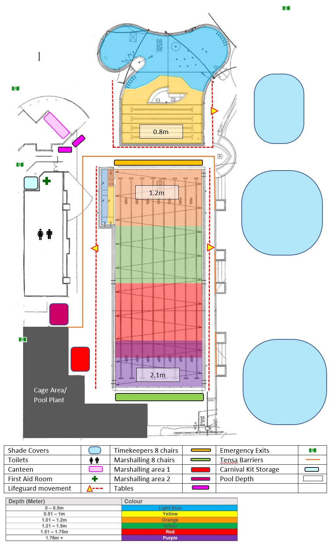

OUTSIDE EQUIPMENT HIRE – WERRIBEE OUTDOOR POOL:

Outside equipment

.1 Barbeques

A Hirer is permitted to bring a barbeque to the facility if:

1.1 The Hirer seeks written approval from us 7 days prior to the commencement of your booking.

1.2 You agree not to use the barbeque for commercial gain.

1.3 You warrant that the barbeque is in good working order and that the barbeque:

1.3.1 has been regularly serviced and maintained; and

1.3.2 will be inspected for any defects or hazards on the day of your booking.

1.4 The Hire agrees to comply with any OH&S requirements applicable to the operation of the barbeque.

1.5 The Hire warrants that they will provide adequate supervision of the barbeque throughout the entirety of its operation.

1.6 The Hire agrees to follow any reasonable directions from us in relation to the operation of barbeque.

EMERGENCY RESPONSE PROCEDURES FOR HIRERS:

When you are notified of an emergency
When alerted to an emergency situation or a situation requiring evacuation: (e.g. fire alarm, or evacuation tone whoop whoop, or verbal advice from the Chief Warden/ Area Warden):
- Follow the instructions of the ECO (Wardens)
- Cease all activities
  - Secure your area (e.g. any activity or process that may become hazardous if left unattended as a consequence of evacuation)
- Assist any person in immediate danger, but only if safe to do so
- Proceed to the designated assembly area
- Await further instructions from the ECO (wardens)
- Do not re-enter until given the “All Clear”
- Follow the instructions of relevant Emergency Services Personnel

If you are the first person on the scene:
- If you are the first on the scene in an emergency situation or a situation requiring evacuation of the facility, please alert centre / site staff immediately.

